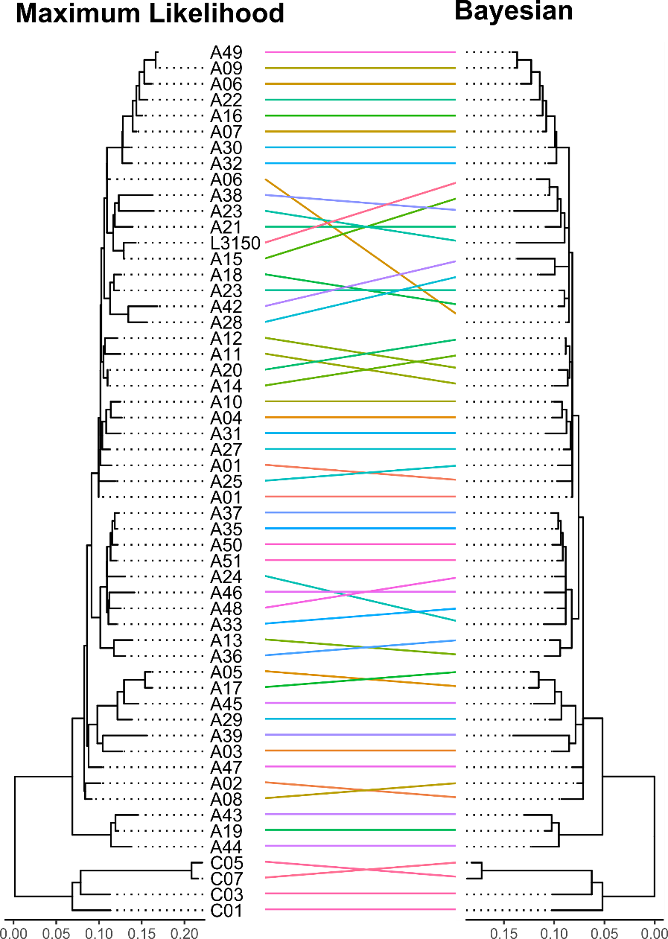
Figure S4. Tanglegram of ML and BI phylogenies (Trebouxia).

