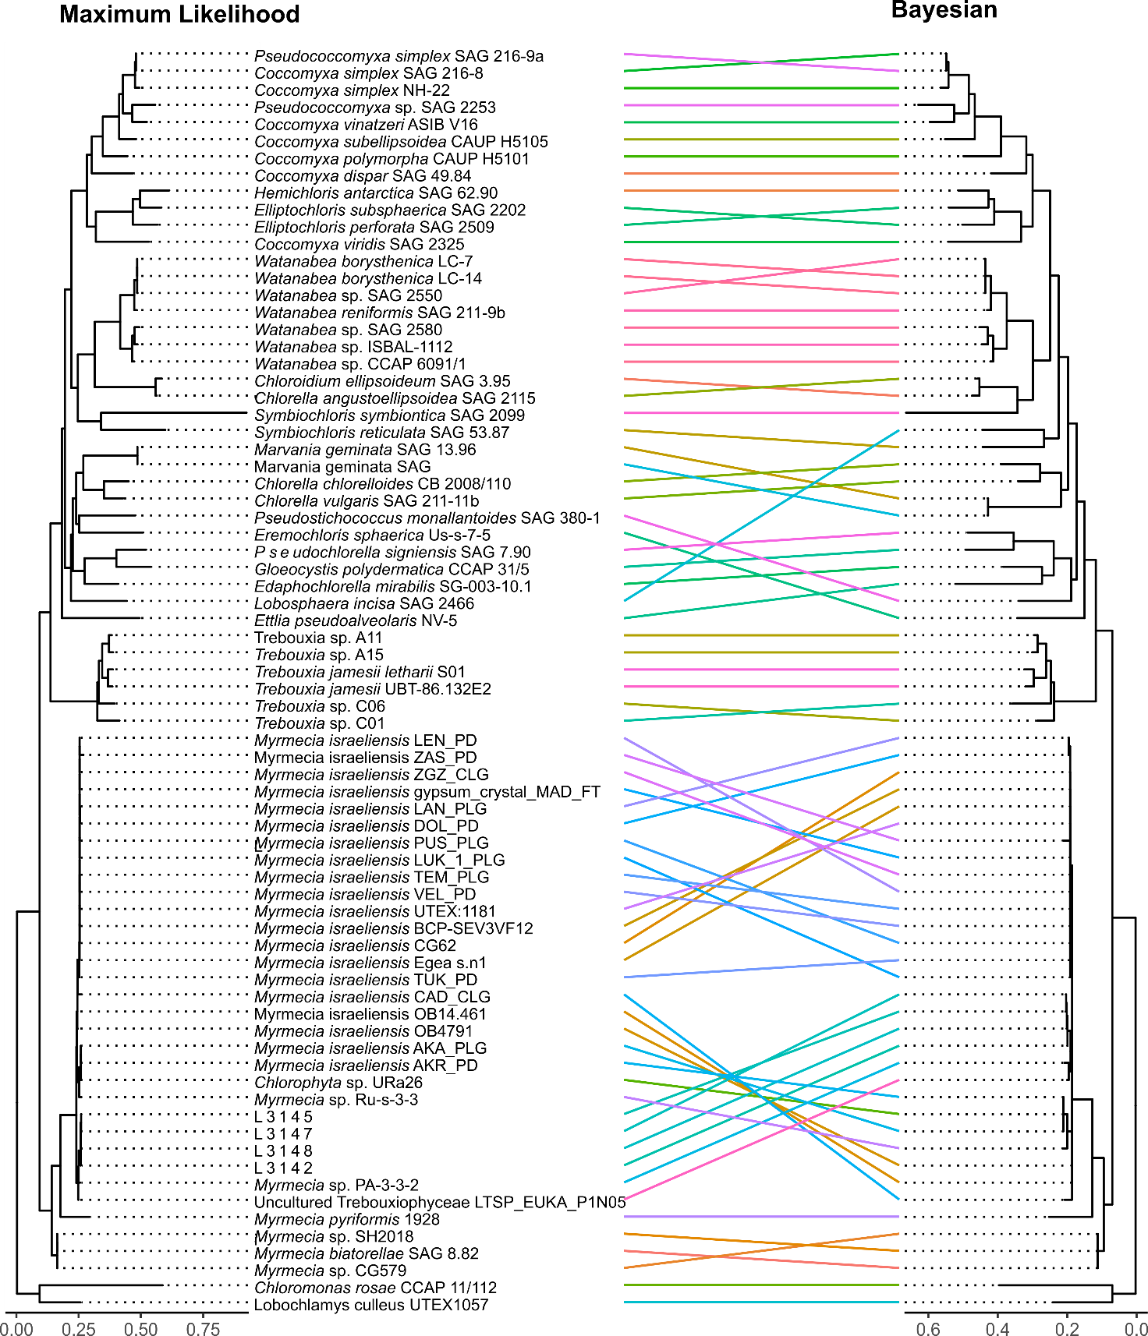
Figure S3. Tanglegram of ML and BI phylogenies (Myrmecia).

