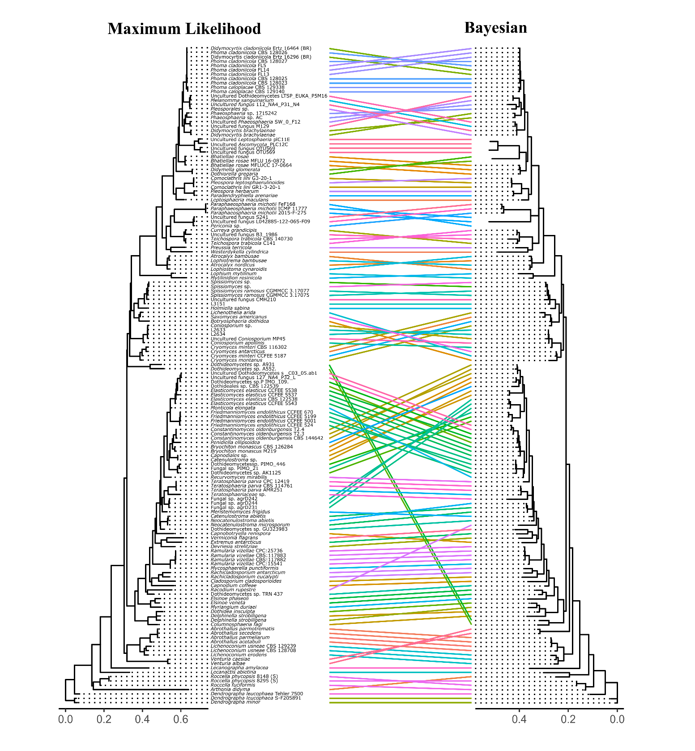Figure S2. Tanglegram of ML and BI phylogenies (Dothideomycetes).

