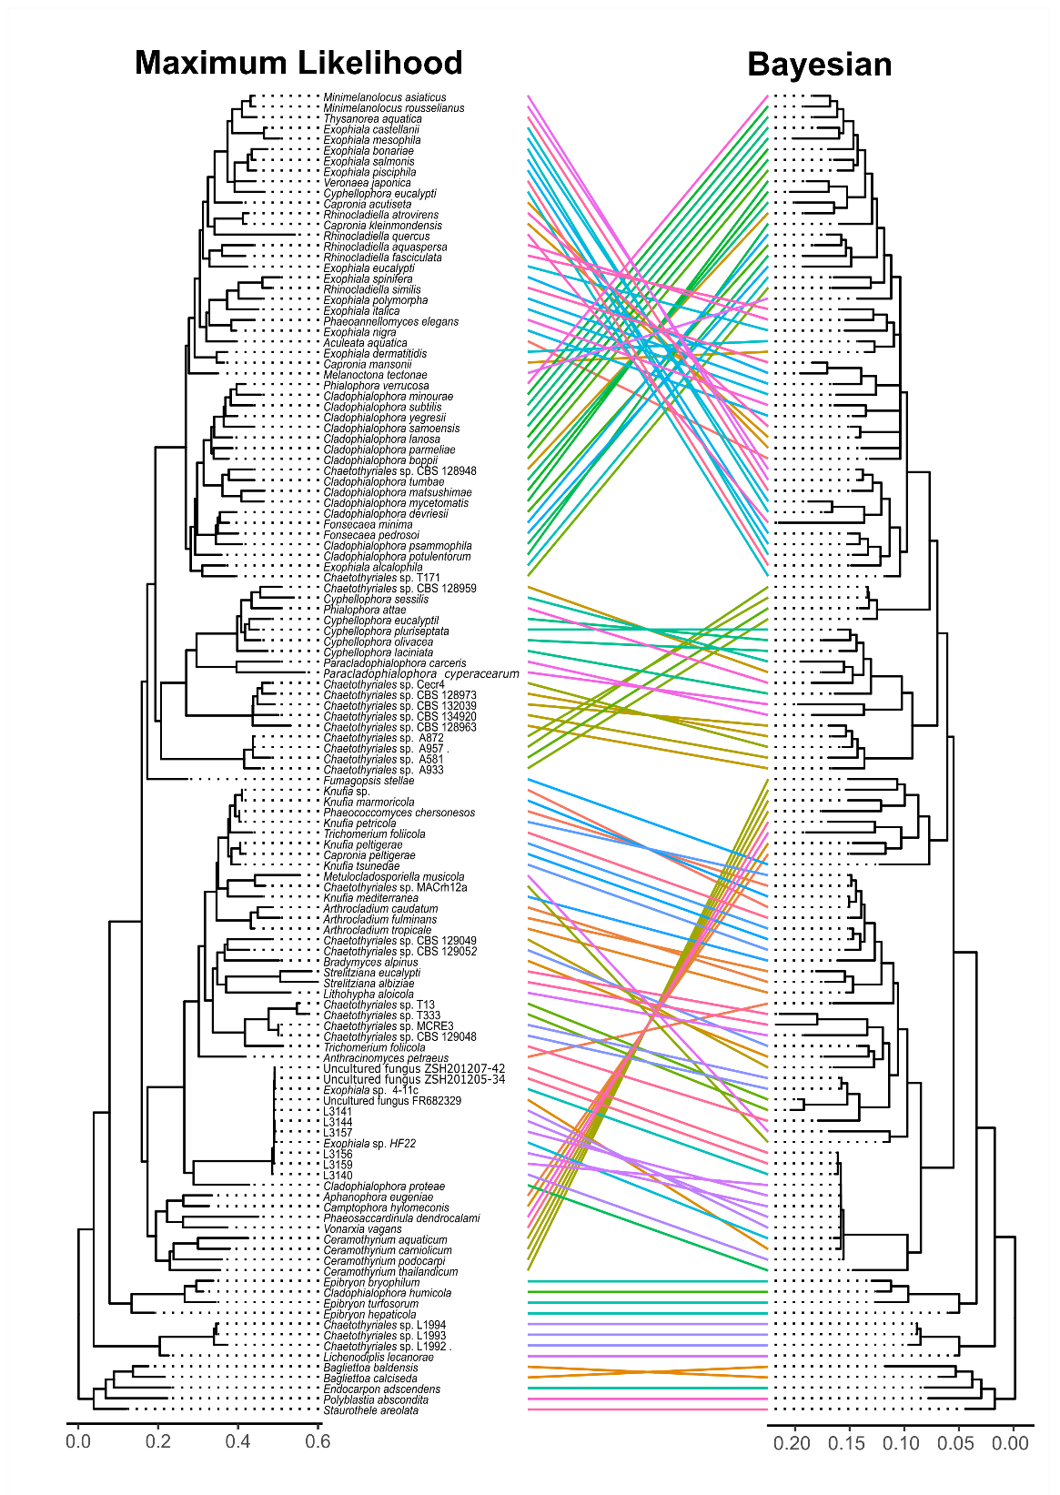
Figure S1. Tanglegram of ML and BI phylogenies (Chaetothyriales).

